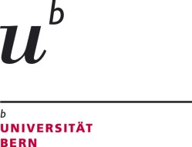
University of Bern
Institute for Marketing and Management
Department of Management

Director: Prof. Dr. Artur Baldauf
Engehaldenstrasse 4
CH-3012 Bern
Tel. 031 631 5331
www.imu.unibe.ch

Application for a Master Thesis at the Department of Management and Entrepreneurship

Surname |  | Name
Address |  | ZIP/City
Phone |  | E-mail
Matr.-no |  | Study core

Please indicate the preferred Topic
Preferred teamwork with
Surname, Name, Matr.-no
Have you applied for a master thesis at another institute/department?  (Please Note: Your application becomes binding if you are accepted to write your thesis at the IMUU.) |  | ☐ Yes ☐ No
Which study regulations (Studienreglement) are applicable in your case? |  | ☐ Regulations of 2004  ☐ Regulations of 2006
Grade „Seminar in Management“*
Number of completed semesters
* or a comparable course (please explain in written form or hand in a copy of the corresponding document)

Place, Date

Please send your application via e-mail to the supervisor of your preferred topic.

Please attach: 1) Your course achievements (Studienblatt) of your master and if possible of your bachelor studies

